|  |  |
| --- | --- |
| A picture of a winding road and trees  ***cxc english language paper 2***  ***Study pack*** | ***HELLO STUDENTS,***  We are finally at the point of application; all our hard work comes down to this- the successful completion of CXC English. Below is a reminder of all we need to navigate paper 2.   1. Summary 2. Expository Writing 3. Essay 4. Letter 5. Email 6. Memo 7. Narrative Writing 8. Persuasive Writing/Argumentative Writing |
|  |  |

***INTRODUCTION:***

The first thing to remember is that the paper will consist of four sections mainly;

Section A – Summary

Section B – Expository

Section C – Narrative

Section D – Persuasive/Argumentative

***NOTE: You will be given 2 hours and 40 mins to complete this.***

***Section A – Summary Writing***

For this section you will be tasked to summarize a passage please remember the following:

* **FORMAT** – The piece given to summarize might come in different ways – prose extract, drama extract etc.
* **ORGANIZATION –** You must write your summary in continuous prose (unless otherwise instructed)
* **RELEVANCE** – Remember that only the most important information should be placed in your summary. Look at it this way, when you read your original the second time, mentally or physically with a pencil, exclude any of the following:

1. Minor details

2. Opinions

3. Repetitions/Redundancies

4. Examples

5. Figures of speech

6. Evaluations/conclusions

7. Dialogue/ Quotations

8. Statistical data

* **SUMMARIZE** – You must be short and concise. Please pay attention to the word limit. It is very important. Your summary is usually 1/3 of your original text.
* **OWN WORDS** – You must use your own words as much as possible. Please remember that words//expressions such as proper nouns and names of institutions/organizations should not be changed

**In addition, you must pay attention to your grammar, mechanics and spelling and:**

* Change any direct speech into reported speech
* Keep the language: (**SC²**)
* **Simple** – easy to understand
* **Clear** – easy to see
* **Concise** – brief and to the point

***CXC RUBRIC FOR MARKING THE SUMMARY WITH SAMPLE***

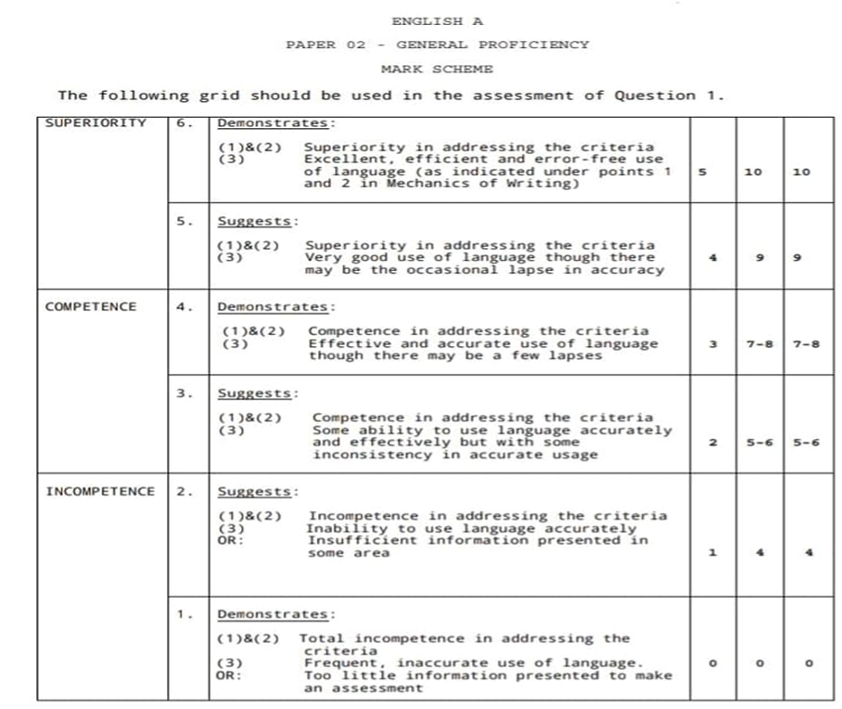

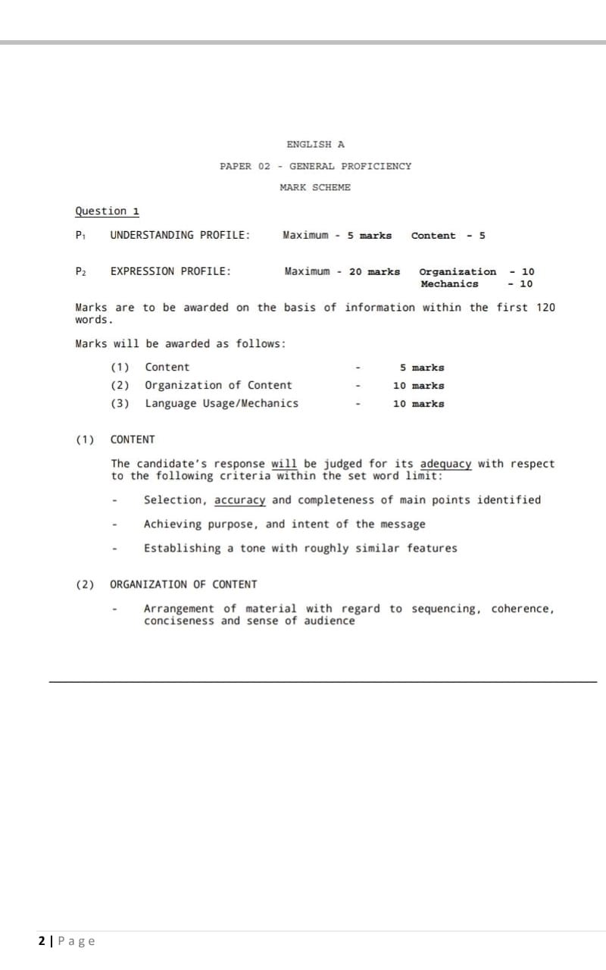

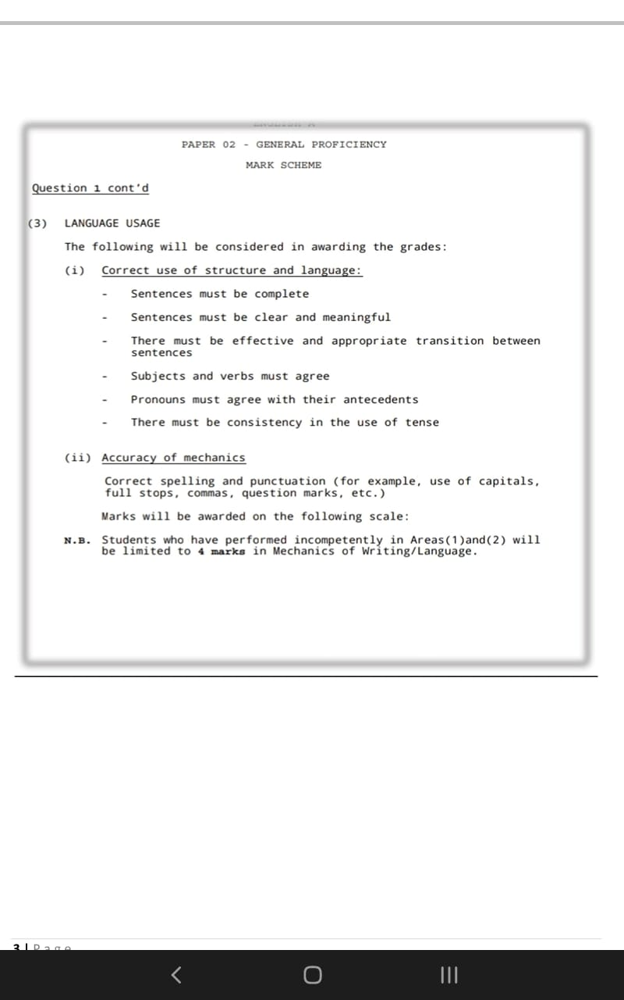

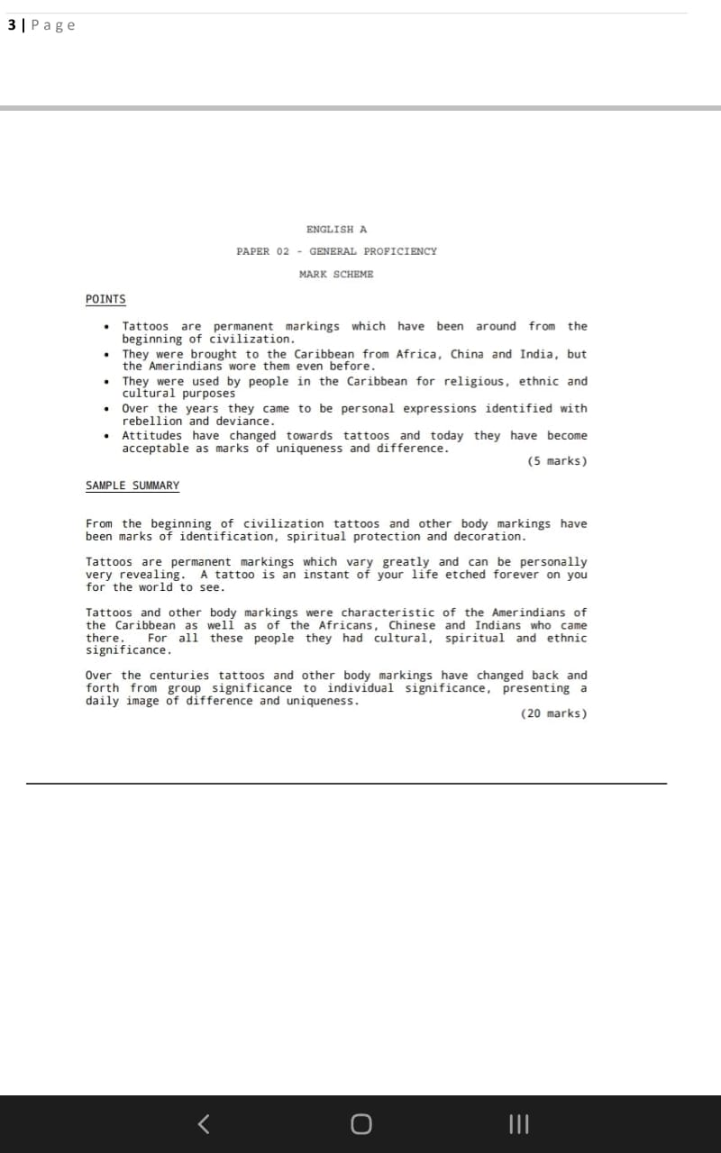

***EXPOSITORY WRITING***

For your expository piece, you could be asked to write one of the following:

1. Expository Essay
2. Letter (Complaint, Request etc.)
3. Email
4. Memo

Below are reminders to help you regardless of the type you get.

***Expository Essay***

***Like most academic essays at this level, you essay has the regular five paragraph structure.***

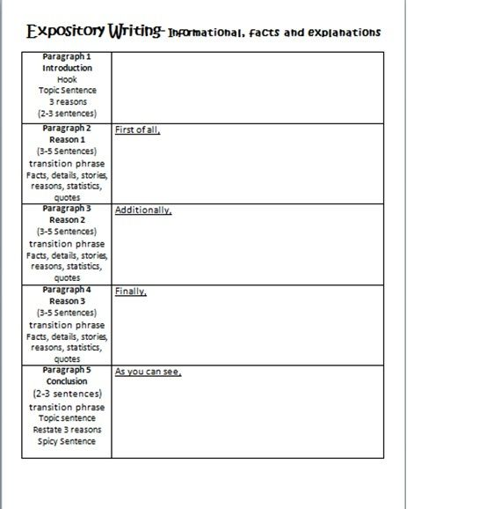

***Sample Persuasive Essay***

**Topic:**

**Staycations allow us to explore the diversity of Jamaica’s natural and cultural heritage. Why it is important for Jamaican’s to experience the Jamaican tourism product?**

“Ooh, I met a girl this morning, she was love at first sight. Ooh, I met a girl this morning, she was beauty to my eyes…”

The popular Jamaican artiste, Chronixx, has immortalized and personified the beauty of our natural heritage of our island, Jamaica, when he sang, “…she was beauty to my eyes, smile girl smile, smile for me Jamaica…” Jamaica is, no doubt, one of the leading tourism countries in the western hemisphere. It is imperative that Jamaicans know what it is that attracts tourists to the island so that they themselves can help to market the product. Staycationing is a great vacationing option for Jamaicans as it is an opportunity for us to enjoy what others can only dream of enjoying; it reunites us with the beauty of our island, and it is less of a hassle.

A Jamaican staycation helps you to rediscover the natural beauty and unique cultural heritage. For example, Accompong in St. Elizabeth and Trelawny town in St. James are two of the many Maroon locations on the island. Maroons are brave people and are perfect examples of the qualities of the Jamaican people. That unique organism that inhabits Glistening waters in Falmouth, Trelawny, can only be found in four places in the world! This tells that Jamaica is special indeed.

A staycation re-establishes bonds that got lost in the shuffle and technological advancement. Many Jamaicans were raised having a strong bond with nature. Usually, when children grow to the age of ‘adulthood’, they seem to forget their childhood and their bond with nature. They lose touch with what nature has bestowed on the island. Their minds move away from the things they used to love, and yes, they do go on vacations, but where? To other countries, and the memories of childhood simply fade away. Having the experience of the Jamaican product can help you market it and give you the ability to let other people learn to appreciate it.

A staycation revives your love for where you live, and you get all the fun of planning and enjoying a vacation without the added expense of travel. It has the potential of being cheaper for example, locals are sometimes charged less, and this adds money to your pocket, while others spend a lot of money to enjoy the same experience. A staycation rejuvenates the memories of the good old days when work, family and stress were not a bother- just the fascinating Jamaica was enough food to fill your mind. Travelling to other countries can be very costly, but why travel abroad when you can party in your homeland and enjoy its features? The rich culture is what adds spice to the island and should be praised because it has come a long way and up to this day, they are still hot and rocking.

A staycation is a good way to discover why tourists love our country and it is a chance to bring back the memories to life. It is an opportunity to find the lost, discover the hidden and learn the unknown things of this powerful, richly cemented island, Jamaica.

***Letter Format and Example***

Glenmore Drive

Claremont P.O.

St. Ann

11th April, 2022

The Manager

Food and Drug Agency

10 North Pole Avenue

Georgetown

Dear Sir/Madam,

**RE: Complaint against Cheap and Sweet Supermarket**

I write to complain against the Cheap and Sweet Supermarket (121 North Pole Avenue) from which I purchased a box of cereal on October 10, 2014. I have two areas of concern: the treatment I received, and the quality of the product.

The item was a sale and I paid $8:45 for it. On arrival home I realized that the product had expired since March, 2012. I returned the package with the bill #123964, and was directed to speak with the supervisor. He quite rudely said that it was my duty as a customer to check any product I wanted to buy. Since I was dissatisfied with such a response, I went to the manager.

I explained the issue and expressed my disappointment to the manager. I also requested a refund but he too told me that I should have checked the date before making the purchase. In addition, he said that their policy is no exchange or refund on sale items. He promised to speak to his colleague, then he dismissed me and went to the telephone.

I believe this treatment is unjust and would like you to intervene to rectify this matter. If such a thing is allowed to continue someone will get hurt (food poisoning). The nation’s health depends on your swift action.

Yours sincerely,

Sandra Brown

***Sample of Letter of Apology***

Coultart Grove

Moneague P.O.

St. Ann

April 13, 2022

The Principal

Ferncourt High School

Claremont P.O.

St. Ann

Dear Mr. Thomas,

***RE: Apology for Negative Behavior in the Office***

I’m writing to you to express my regret for my behavior on April 7, 2022 in regards to outburst in the main office. I would like to apologize for my words and actions and reassure you that such an event will not happen again.

On the date in question, I got into a verbal altercation with the head waiter about the scheduling, and this led to my inexcusable behavior. I have already apologized to Mrs. Burey and I wanted to assure you that I will work to improve my reactions and behavior in the future.

I’d be happy to meet with you to speak about the incident further if you have any outstanding concerns.

Respectfully,

P. Clarke

Patricia Clarke

***EMAIL FORMAT WITH EXAMPLE***

From: [patriciaclarke230@yahoo.com](mailto:patriciaclarke230@yahoo.com)

TO: [sanhaverton@gmail.com](mailto:sanhaverton@gmail.com)

CC: [lifeforhumanity@gmail.com](mailto:lifeforhumanity@gmail.com)   
BCC: [helpdesk123@gmail.com](mailto:helpdesk123@gmail.com)

Subject: ***Request for Donation for Local Residents***

Dear Mr. Haverton,

I am writing on behalf of Help for Humanity. As you may know, we help local residents who need clothing, personal items, or household items.

I am writing to ask you to consider donating to “Help for Humanity.” Your assistance will help your neighbors in need by offering them basic necessities. Often these neighbors do not have the items required to maintain a household or the clothing needed to seek and maintain employment.

You can help by donating your unused clothing or household items to our organization. Our drop-off point is located at 3098 West 93rd in Booneville. You can also help by sending a financial donation in any amount in the postage-paid envelope provided, or by calling 924-398-4200 with your payment information. Any donation, no matter how small, helps local residents meet their needs.

Thank you so much for taking the time to read this and consider my request. Your assistance is greatly appreciated.

Respectfully yours,

A. Jennings

Alicia Jennings

***MEMORANDOM***

**TO:** All staff

**FROM:** Leila Smith, General Manager

**DATE:** February 18, 2022

**SUBJECT:** Recurring Data Security Issues

It has come to my attention that the company has experienced a series of data breaches in the last two weeks because of the recent change in our firewall security system. I know some of you have lost files on your workstations and there has been at least an accidental leak of sensitive company information. We are taking steps to address the issue to prevent further data security lapses.

In the meantime, we are switching to a temporary data management system until our engineers and external consultants can fix the problem. We welcome comments and suggestions on how to solve this problem so we can get back to delivering results for our customers.

Thanks for your understanding.

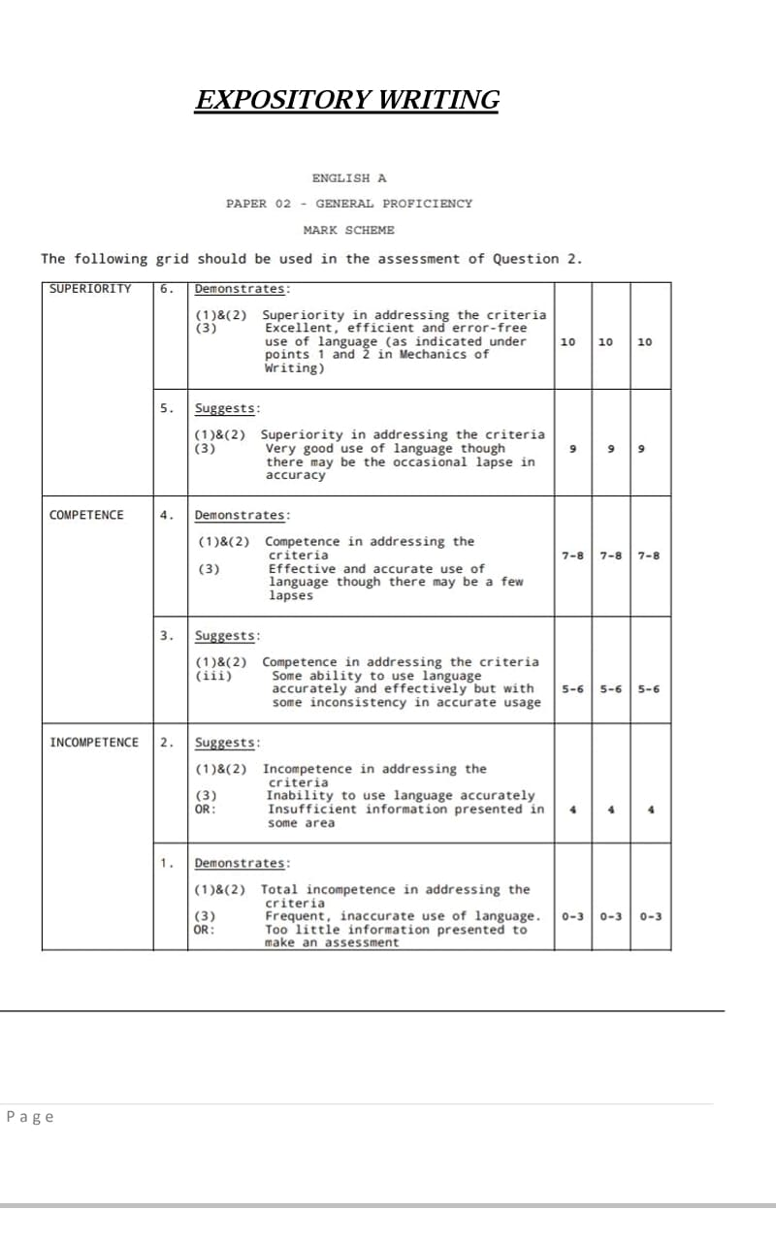

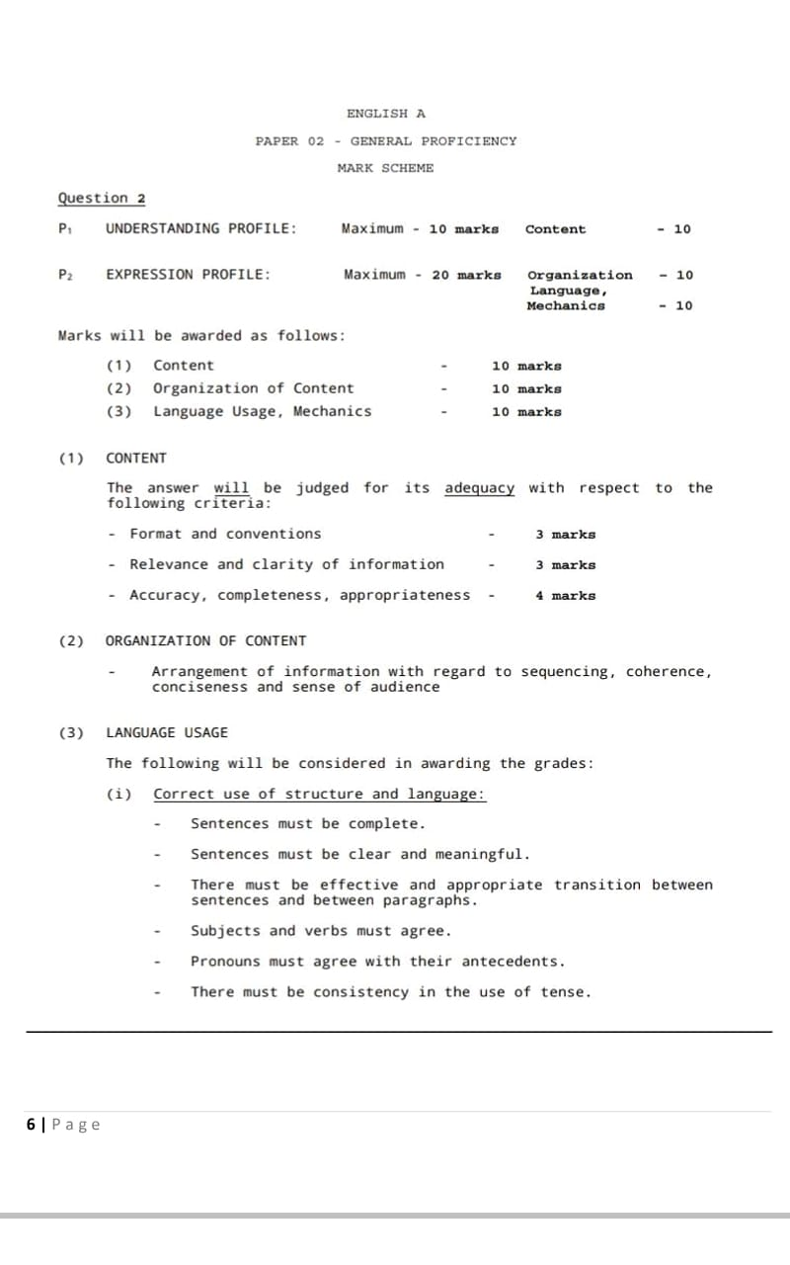

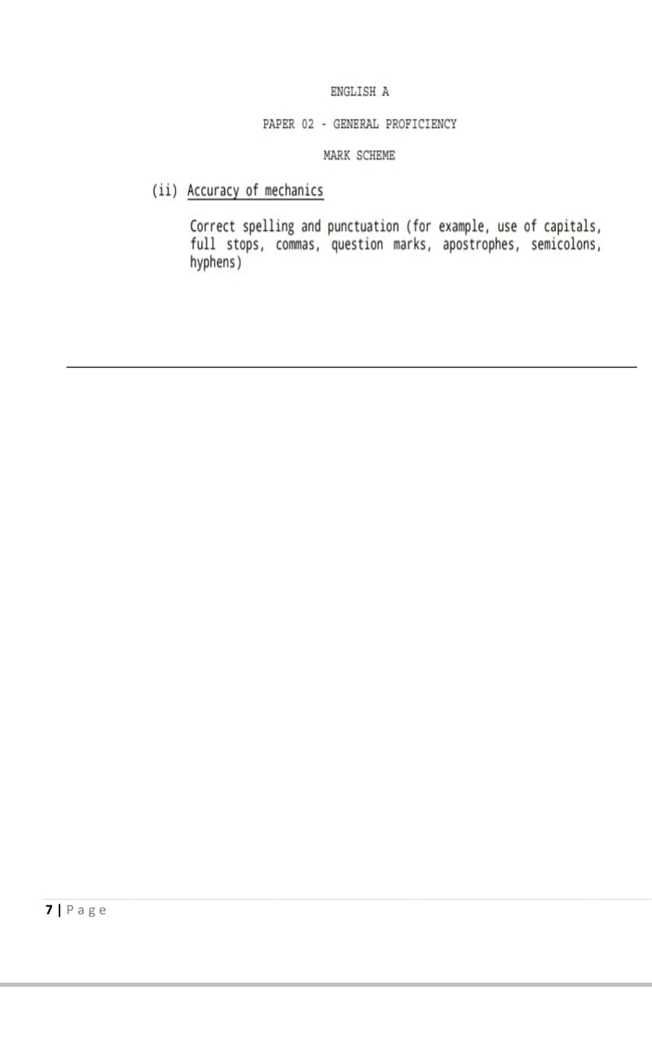

***NARRATIVE WRITING***

Questions three and four on your paper will be the narrative pieces. In order to write a well-structured story, here are some steps to remember:

1. The Writing Prompt/Stimulus

***Picture stimulus:***

Always give a short description of what is portrayed in the photo given.

***Worded stimulus:***

Always reproduce the sentence(s) as they are given on the question paper. No additions (transitions or sentences), adjustments (changing present to past tense or 1st to 3rd person P.O.V.) or subtractions (leaving out words or entire sentences) should be made.

2. The Title of YOUR Story

If you were the one who "made up" your title for your story, then:

a) Make it catchy and memorable

b) Place it at the top, center of your page (skip one line after to begin your composition)

c) Do not underline it

d) Do not place it in quotation marks

e) Do not forget to write it

3. The Question Number

At the top of your exam paper, you are required to write the question number for the prompt that you chose on all the pages you will be writing. It is important for you to always put the correct number for the question/prompt chosen.

4. The Word Count – Stick to the word count.

5. Paragraphing

In a short story, make a NEW PARAGRAPH for the following:

* New Time (setting)
* New Place (setting)
* New Speaker
* Action That Serves As Part of the Dialogue
* Dramatic Effect

6. Counter writer’s block by describing your character or setting.

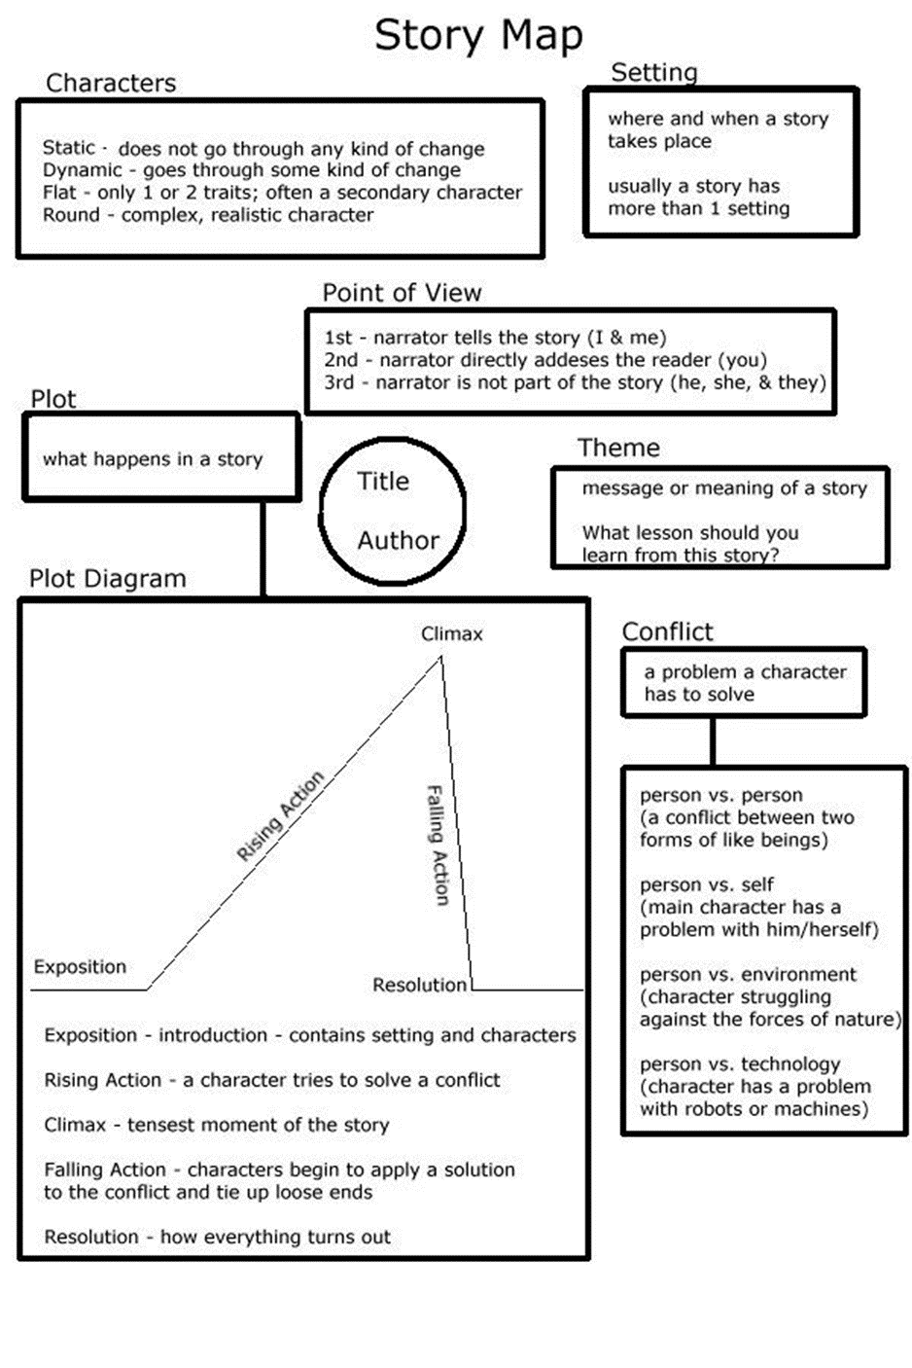

***SAMPLE CXC SHORT STORY***

This story was written in response to the following question: “Some people never give up. They keep going on and on.” Write a story beginning with these words.

***The Lesson***

“Some people never give up. They keep going on and on and on. People of this caliber have forged themselves a place in history’s archives, boys, and if you live up to the challenge, so will you. Do your country proud.”

THE words of the arrogantly confident field commander whistled through his ears as a landmine exploded behind him. The blast of choking Sulphur and ash rocked him, sending him to his knees on the ground. The screeches of Arabic curses seared his mind; he closed his eyes and wondered, “Is this what going on means?” How ironic it was that the passionate speech, fired with patriotism, had been given what felt like centuries ago, on the soil of a country he doubted his feet would ever kiss again. How ironic that he, a humble field soldier, now gambled with his life and a dubious metallic weapon, on the battlefield of someone else’s war, while the illustrious commander was tucked safely home, no doubt commenting gravely on the exploits of ‘our boys out there’.

He struggled to rise to his feet at the same time dreading the visual Holocaust sure to assail him. The center of the town’s once prosperous financial district had been transformed into a base of squalor and destruction, where blood ran in the gutters instead of water … oh, for a taste, a drop of water, the soldier thought, raising his eyes to the relentlessly blazing Middle-Eastern sun. Mere feet away from him, children garbed in tattered rags kicked at the remains of a decaying mongrel. The stench of putrescence that rose from its desiccated limbs ought to have made them vomit, but they surely had nothing to expel from their empty bellies save gastric acid. Surely these people were promised food from my country, he wondered, the benevolent gesture of a superior nation, confident of its victory? No … then it seems the first casualty of war is truth.

A sudden, horrendous shriek rent the oppressive, steamy silence; the soldier whirled around, hands clutching his rifle. A hideous figure that might once have been called a woman, except for the torture marks of poverty and suffering carved into her frame, staggered through the street. Her skeletal arms were raised to the blazing skies above as if in praise, yet the sorrow imbedded in her deep onyx eyes made it clear she had nothing to rejoice for. The soldier followed her line of vision, seeing a young girl, of perhaps five years old, being detained by one of his colleagues, some meters away. He remembered that some of the local

Suddenly, without warning, the soldier up ahead slapped the child resoundingly about the face. Her little neck jerked backwards, as her head bobbed from side to side with the force of his blows. Piteous, moaning sounds escaped her mouth. Horrified, the young officer called out to his colleague to cease abusing the infant, but his reaction was overshadowed by that of the woman.

Imprecations burst from her mouth as she sprang forward with more energy than her emaciated limbs could possess. Angry, violent flames burned in her eyes in the place of sorrow, as her bare feet slapped the gravel of the ground. She cleared the distance in seconds, snatched the weeping child from her oppressor’s grasp with a fierce snarl, like a lioness would make when she discovers one of her cubs has been maltreated. The young soldier was amazed to see that her soles were bleeding, that lesions and gaping cuts peered from the bedraggled fabric of her dress. He tried to remember if he had ever seen anyone so strong, wondered if the commander he had once idolized would behave like this, to protect something he loved. He stood in the middle of the street, applauding silently as the woman and child made a hurried getaway, past the rubble of a destroyed building. He turned his back on his enraged counterpart and began walking off.

The burst of gunfire rooted him to the spot; he prayed to a god he had stopped believing in even as he heard the other man mutter, “That’ll teach you, you blasted woman”. He continued to stand still as the other’s booted steps grew ever distant, fading into the background. Had he gone to slaughter more innocents, the soldier thought, is this the bleeding face of humanity laid bare?

The woman and child lay on the ground some distance away. Their bodies were folded together, intertwined with Death’s gentle hands into a final embrace. Their souls fled to a place where suffering was but a nasty memory, where freedom lasted forever. The young soldier, once lit with shimmering ideals, once burning with desire to fight, to win, stood looking at their bodies, for a second, for a year. Though he was not dead, he felt part of his own soul flee his body, in disgust at the sight of what people did to other people. He leaned over and closed the eyes of the woman, realizing bitterly that her example of ‘never giving up’ had been more real and pure than any exhortations of a vainglorious commander.

“You”, he said to her lifeless body, with more conviction than he had ever felt, “have taught me what it means to go on”.

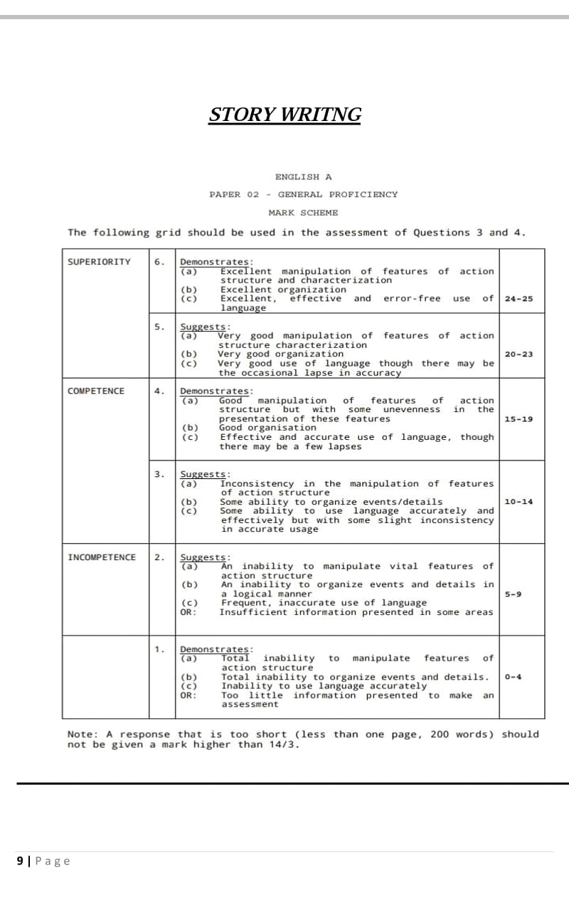

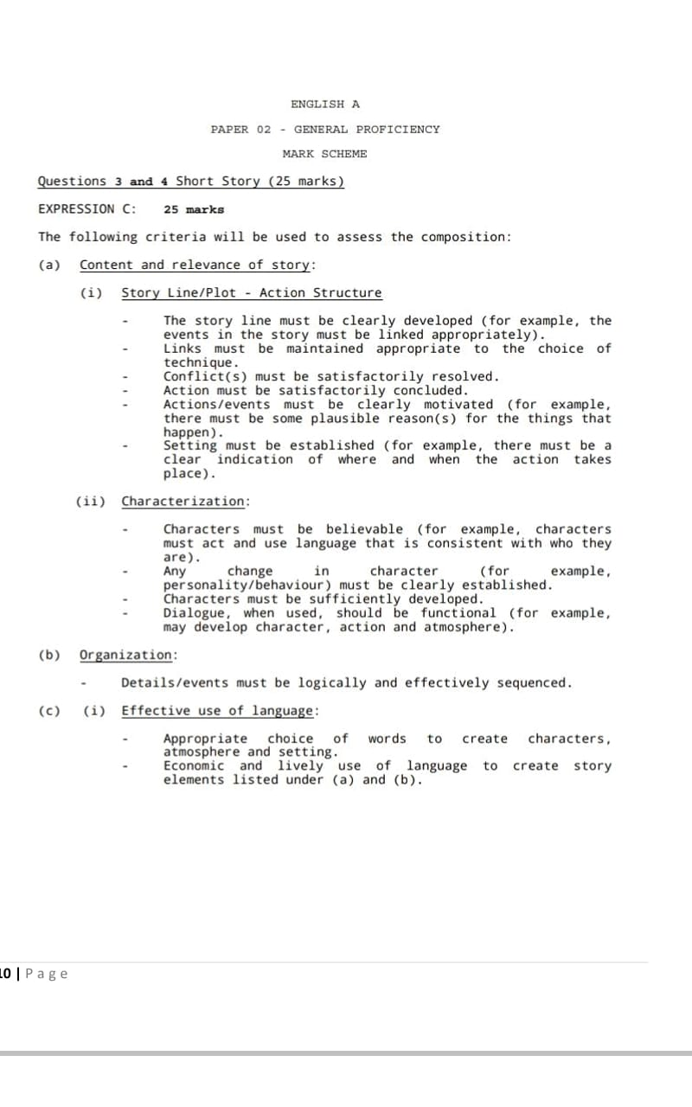

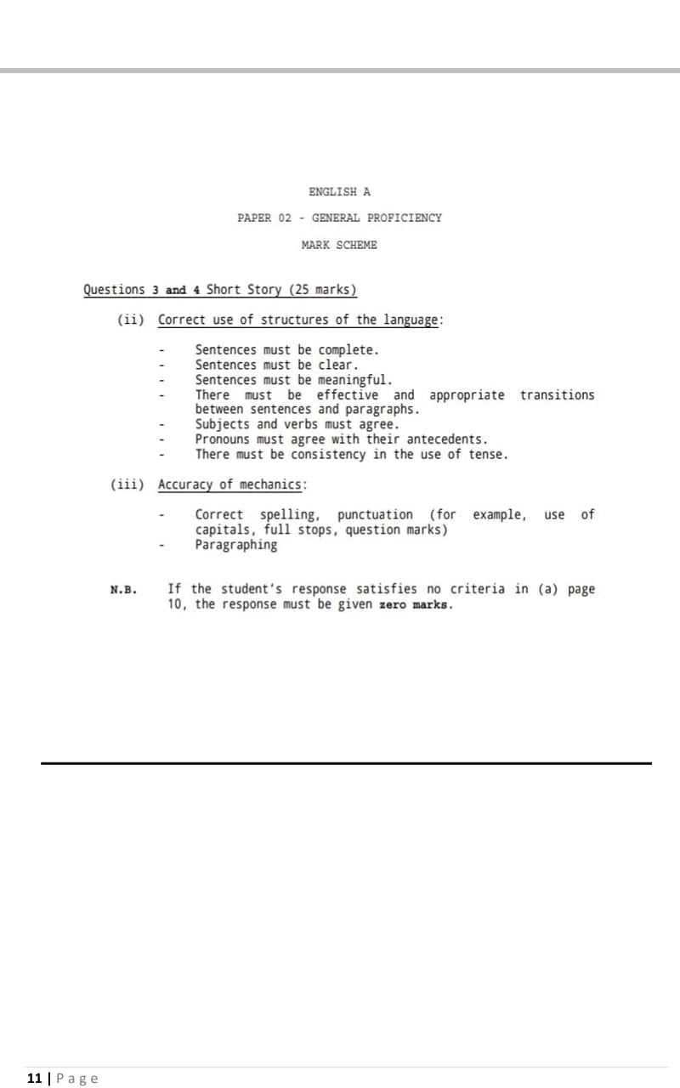

***PERSUASIVE/ARGUMENTATIVE ESSAY***

The final question will be a persuasive/argumentative essay. The main thing to remember here are:

**ARGUMENTATIVE PERSUASIVE**

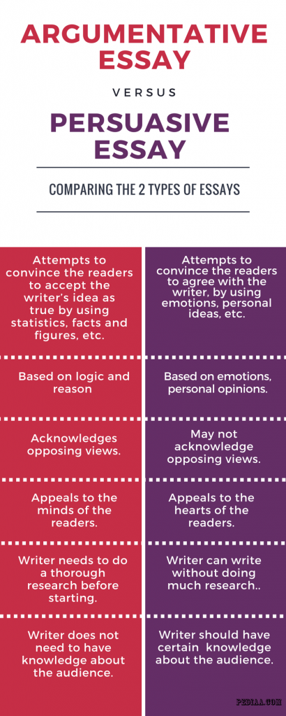

*Remember to use appropriate persuasive technique and transitional words/phrases to make your essay credible/believable/convincing and to ensure coherence

***Persuasive Essay Outline and Example***

**Graphic Organizer: Persuasive Essay**

|  |
| --- |
| **Introduction Paragraph**  **Hook**: **Circle Type Used**: **Snapshot** (paint a picture, like a photograph so the reader can see it), **Anecdote**, (a short often humorous or real life story) **Quote** (a famous quotation or saying, for example, “No pain, no gain), **Dialogue** ( create a scene in which two or more people are talking, **Question**,(Ask a question that is reasonable for the reader to answer) or a **Bold & Challenging** Statement (*For example, Using horses and cattle in the sport of rodeo is animal abuse. What makes it more aggravating is that it is legal. According to the law, there is nothing wrong with chasing an animal down, tightening a rope around its neck, knocking it to the ground, and tying its legs together so it cannot move*.”) |
| **Context:** (A little background information the reader needs to know) |
| **I Believe Statement:** Create one sentence with three reasons from your T Chart that you will develop and support throughout the essay. |
| **Supporting Paragraph for 1st part of your believe statement**  ***Topic Sentence (topic and opinion)***  ***At least three supporting details - directly related to topic of paragraph***        ***Concluding Sentence (wraps it up)*** |
| **Supporting Paragraph for 2nd part of your believe statement**  ***Topic Sentence (topic and opinion)***  ***At least three supporting details - directly related to topic of paragraph***        ***Concluding Sentence (wraps it up)*** |
| **Supporting Paragraph for 3rd part of your believe statement**  ***Topic Sentence (topic and opinion)***  ***At least three supporting details - directly related to topic of paragraph***        ***Concluding Sentence (wraps it up)*** |
| **Conclusion**: (Remember, this has two parts. It must restate the focus in new words and leave the reader thinking – the “aha moment.” A final statement, a call to action (ask them to do something or offer a solution to the problem.) |
|  |

***Sample Essay***

The Perfect Pet

"A dog is man's best friend." That common saying may contain some truth, but dogs are not the only animal friend whose companionship people enjoy. For many people, a cat is their best friend. In this essay I will argue that cats make excellent house pets as they are good companions, civilized members of the household, and easy to care for.

In the first place, people enjoy the companionship of cats. Many cats are affectionate. They will snuggle up and ask to be petted, or scratched under the chin. Who can resist a purring cat? If they're not feeling affectionate, cats are generally quite playful. They love to chase balls and feathers, or just about anything dangling from a string, and they especially enjoy playing when their owners are participating in the game. Contrary to popular opinion, cats can be trained. Using rewards and punishments, just like with a dog, a cat can be trained to avoid unwanted behavior or perform tricks. Cats may even learn to fetch!

Secondly, cats are civilized members of the household. Unlike dogs, cats do not bark or make other loud noises. Most cats don't even meow very often. They generally lead a quiet existence. Cats also don't often have "accidents." Mother cats train their kittens to use the litter box, and most cats will use it without fail from that time on. Even stray cats usually understand the concept when shown the box and will use it regularly. Cats do have claws, and owners must make provision for this. A tall scratching post in a favorite cat area of the house will often keep the cat content to leave the furniture alone. As a last resort, of course, cats can be declawed.

Lastly, one of the most attractive features of cats as house pets is their ease of care. Cats do not have to be walked. They get plenty of exercise in the house as they play, and they do their business in the litter box. Cleaning a litter box is a quick, painless procedure. Cats also take care of their own grooming. Bathing a cat is almost never necessary because under ordinary circumstances cats clean themselves. Cats are actually more particular about personal cleanliness than most people are. In addition, cats can be left home alone for a few hours without fear. Unlike some pets, most cats will not destroy the furnishings when left alone. They are content to go about their usual activities until their owners return.

In conclusion, cats are low maintenance, civilized companions. People who have small living quarters or less time for pet care should appreciate these characteristics of cats. However, many people who have plenty of space and time still opt to have a cat because they love the cat personality. Therefore, in many ways, cats are the ideal house pet.

***ARGUMENTATIVE OUTLINE AND EXAMPLE***

***When asked to argue for or against***

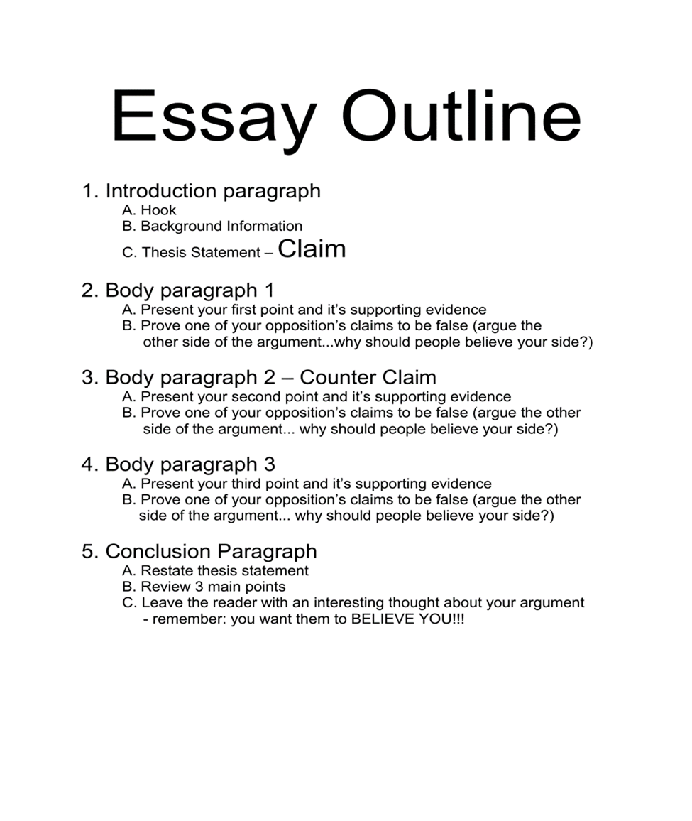

***SAMPLE ESSAY***

***Topic:***

For the 21st century learners, online learning is better and more effective than face to face learning.

Argue for or against this stance.

***Online classes are better than face to face classes***

Online learning is one of the 21st century’s greatest phenomenon. It allows learners to study in the comfort of their own home. This makes it better than face to face learning as: it is affordable, less hassling and more fun.

As it is relates to affordability, online learning has taken the financial stress off hard-working parents to find daily school supplies. It allows parents to spend their limited funds on necessities that will benefit the entire household. Some might argue that there will be a higher demand to supply on groceries when children are home. While factual, it is highly unlikely for the cost of groceries to outweigh the cost of transportation, lunch and other school necessities.

In addition, online classes replace the hassle of travelling for children. Many children are forced to be up extremely early to travel to school and are home very late. This undoubtedly makes them very tired and can affect their performance at school. Being at home gives them the opportunity of rest and subsequent higher performance. While it is true that travelling to school has social benefits to students, these same benefits can be derived through community involvement and quality family time.

Furthermore, online learning is far more fun than face to face classes. Students nowadays are technologically savvy; thus, they will gravitate to online learning easily over sitting in boring classrooms. Many may argue that it robs students of the ability to collaborate. However, collaboration is possible online through the use of sharing apps like Google Docs, and will even allow teachers to better track students’ progress and contribution to group activities.

Essentially, online learning is better than face to face learning because it is less expensive, stress is at a minimum and it makes learning enjoyable. Learning from home is an opportunity that should be promoted for sustainability.

***ADVANTAGES AND DISADVANTAGES GRAPHIC ORGANIZER***

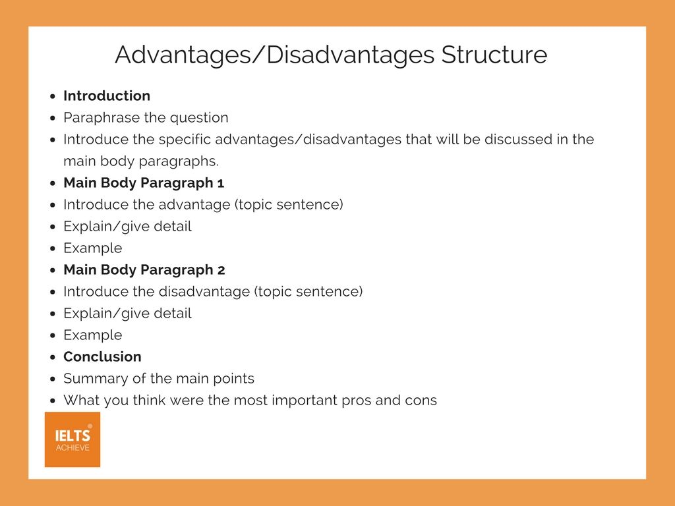

**Sample Essay**

​

Write about the following topic:

***Many elderly people are no longer being looked after by their families, rather they are living in nursing homes. What are the advantages and disadvantages of this trend?***

Give reasons for your answers and include any relevant examples from your own knowledge or experience.

***Pros and Cons of Nursing Homes***

Getting old is one of the most natural and universal human phenomenon. Despite this, families are consistently missing the opportunity to plan for this critical part of their live one’s life. As a result, an increasing number of senior citizens in today’s society are not being taken care of by their immediate family; instead, they are residing in care establishments. This essay will analyze the positive and negative aspects of this trend.

On a positive note, elderly peoples’ physical and mental well-being are carefully monitored and evaluated by trained professionals in residential homes. Scientific research clearly identifies that most people over the age of 60 suffer from potentially serious health issues such as cardiovascular diseases. Care facilities, however, have suitably qualified medical personnel and equipment to meet these challenges. Additionally, from a psychological perspective, residents’ mental health is stimulated through living in a community where there is potential for positive camaraderie with like-minded individuals.

On the other hand, there are several drawbacks to elderly people living in nursing homes that affect both themselves and their family members. For instance, being apart from their immediate family, on a daily basis, can result in unpleasant emotions such as feelings of isolation and being undervalued as a family member. The expense of care homes, in addition, can impose a serious financial burden on the family. In my country, for example, a one-month’s stay usually costs 3000 dollars with other charges excluded. Consequently, the majority of people on low incomes usually have no choice but to take care of elderly family members by themselves.

In conclusion, homes for the aged provide geriatric patients with professional medical services that potentially prolong their lives. The challenges, however, include feelings of abandonment amongst residents along with the unmanageable financial costs to their families.

